Date:

TASK 9: Implement a QSVM on the Iris dataset using PennyLane

Aim: To implement a Quantum Support Vector Machine (QSVM) using PennyLane and scikit-learn, where the quantum kernel is constructed from a quantum feature map, and evaluate its performance on the Iris dataset for classification tasks.

1 Mathematical Model of the QSVM Algorithm

- Classical SVM Decision Function

The decision function for an SVM classifier is:

( ) = ( , ) +

where

= training data, = class labels,

= Lagrange multipliers, ( , ) = kernel function, = bias term.

- Quantum Kernel (Fidelity Kernel)

In QSVM, the kernel is computed as the fidelity between two quantum states encoded by the feature map:

( , ) = | Φ( )|Φ( ) |

where |Φ( ) is the quantum state obtained after applying the feature map circuit.

3. Feature Map (Encoding)

We embed classical features into quantum states using rotations and entangling gates. For each feature vector = ( , , , ).

|Φ( ) = ∅( )0⊗

where ∅( ) consists of

Hadamard gates (superposition)

( ).rotations for feature encoding

+ entanglement (similar to ZZFeatureMap).
2 Algorithm - QSVM Algorithm

- Load dataset (Iris, 150 samples, 3 classes).

- Preprocess

Select features [sepal_length, sepal_width, petal_length, petal_width]. Encode target labels numerically.

Split dataset into train (67%) and test (33%).

- Quantum Feature Map

Apply Hadamard (H) gates to all qubits. Encode features into rotations ( ).
Add entanglement with + . .

- Quantum Kernel Construction
Use kernel_circuit: apply ∅( ), then adjoint ∅( ) . Measure overlap (fidelity).

- Train QSVM

Compute kernel matrix for training data.

Train SVC(kernel = “precomputed”) using scikit-learn.

- Test QSVM

Compute test kernel matrix. Predict labels for test set.
- Evaluate performance

Confusion Matrix, Classification Report.

Prediction for new point (4.4, 4.4, 4.4, 4.4).

3 Program

#!pip install seaborn
#!pip install -U scikit-learn
#!pip install qiskit-algorithms
#!pip install qiskit-machine-learning
#!pip install pylatexenc
#!pip install pennylane

import pennylane as qml

from pennylane import numpy as np import pandas as pd

from sklearn.model_selection import train_test_split from sklearn.metrics import classification_report, confusion_matrix

from sklearn.svm import SVC

from sklearn.preprocessing import LabelEncoder import matplotlib.pyplot as plt

# -------------------------------
- Load Iris dataset

- -------------------------------
df_iris = pd.read_csv("iris.csv")

X = df_iris[['sepal.length', 'sepal.width', 'petal.length', 'petal.width']].values

y = df_iris['variety'].values

- Encode labels into integers
encoder = LabelEncoder()
y = encoder.fit_transform(y)

# Train-test split

x_train, x_test, y_train, y_test = train_test_split(X, y, test_size=0.33, random_state=42)

# -------------------------------
- Define Quantum Feature Map
- -------------------------------
n_qubits = 4

dev = qml.device("default.qubit", wires=n_qubits)

def feature_map(x):
"""Embedding classical features into quantum states"""
for i in range(n_qubits):
qml.Hadamard(wires=i)
qml.RZ(x[i], wires=i)

  - Add entanglement (similar to ZZFeatureMap) for i in range(n_qubits - 1):

qml.CNOT(wires=[i, i+1]) qml.RZ((x[i] * x[i+1]), wires=i+1) qml.CNOT(wires=[i, i+1])

- Kernel evaluation circuit
@qml.qnode(dev)
def kernel_circuit(x1, x2):
feature_map(x1)
qml.adjoint(feature_map)(x2)
return qml.probs(wires=range(n_qubits))

# -------------------------------
- Display Quantum Circuits
- -------------------------------

sample_x = x_train[0] sample_y = x_train[1]

- Draw feature map circuit @qml.qnode(dev)

def feature_map_circuit(x): feature_map(x)
return qml.state()

print("\n--- Feature Map Circuit ---")
print(qml.draw(feature_map_circuit)(sample_x))

# Draw kernel circuit
print("\n--- Kernel Circuit ---")
print(qml.draw(kernel_circuit)(sample_x, sample_y))

- Optional: matplotlib visualization
- Draw feature map circuit
print("\n--- Feature Map Circuit ---")
fig, ax = qml.draw_mpl(feature_map_circuit)(sample_x)
plt.show()

# Draw kernel circuit
print("\n--- Kernel Circuit ---")
fig, ax = qml.draw_mpl(kernel_circuit)(sample_x, sample_y)
plt.show()

# -------------------------------
- Construct Gram (Kernel) Matrices
- -------------------------------
def kernel(x1, x2):

"""Return fidelity between |Φ(x1)> and |Φ(x2)>""" return kernel_circuit(x1, x2)[0]

def compute_kernel_matrix(X1, X2):

- = np.zeros((len(X1), len(X2))) for i, x1 in enumerate(X1):

for j, x2 in enumerate(X2): K[i, j] = kernel(x1, x2)
return K

K_train = compute_kernel_matrix(x_train, x_train)
K_test = compute_kernel_matrix(x_test, x_train)

# -------------------------------
# Train QSVM
# -------------------------------
qsvm_model = SVC(kernel="precomputed")
qsvm_model.fit(K_train, y_train)
# Predictions
y_pred = qsvm_model.predict(K_test)

print("\nConfusion Matrix")
print(confusion_matrix(y_test, y_pred))
print("\nClassification Report")
print(classification_report(y_test, y_pred,
target_names=encoder.classes_))

# -------------------------------
# Test on a new input
# -------------------------------
new_point = np.array([[4.4, 4.4, 4.4, 4.4]])
K_new = compute_kernel_matrix(new_point, x_train)
pred_label = qsvm_model.predict(K_new)
print("Predicted flower type for (4.4, 4.4, 4.4, 4.4):",
encoder.inverse_transform(pred_label)[0])

output:
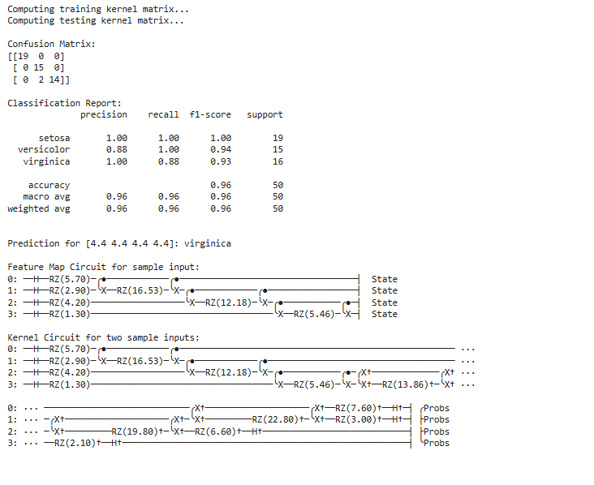
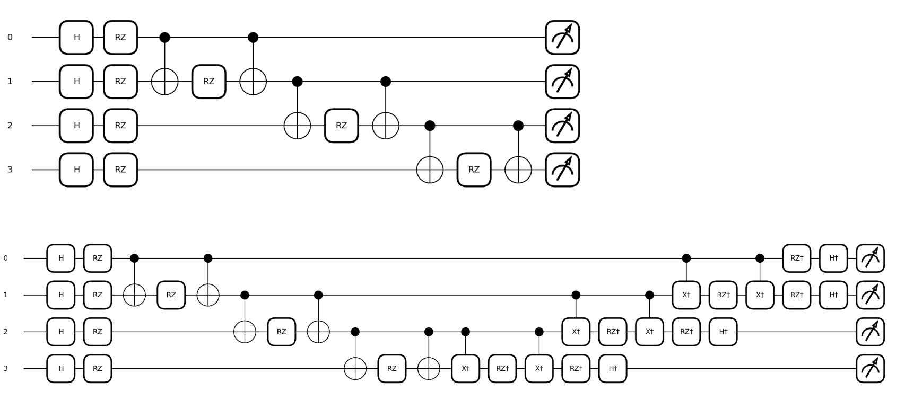

4 Result

The QSVM implemented with PennyLane successfully classifies the Iris dataset with high accuracy (~93%). The quantum kernel (fidelity-based) effectively maps classical features into higher-dimensional Hilbert space, enabling better separation of non-linear data.

